Велков, Ив. Две новооткрити римски дипломи от Веспасиана. ИАИ, ІІ
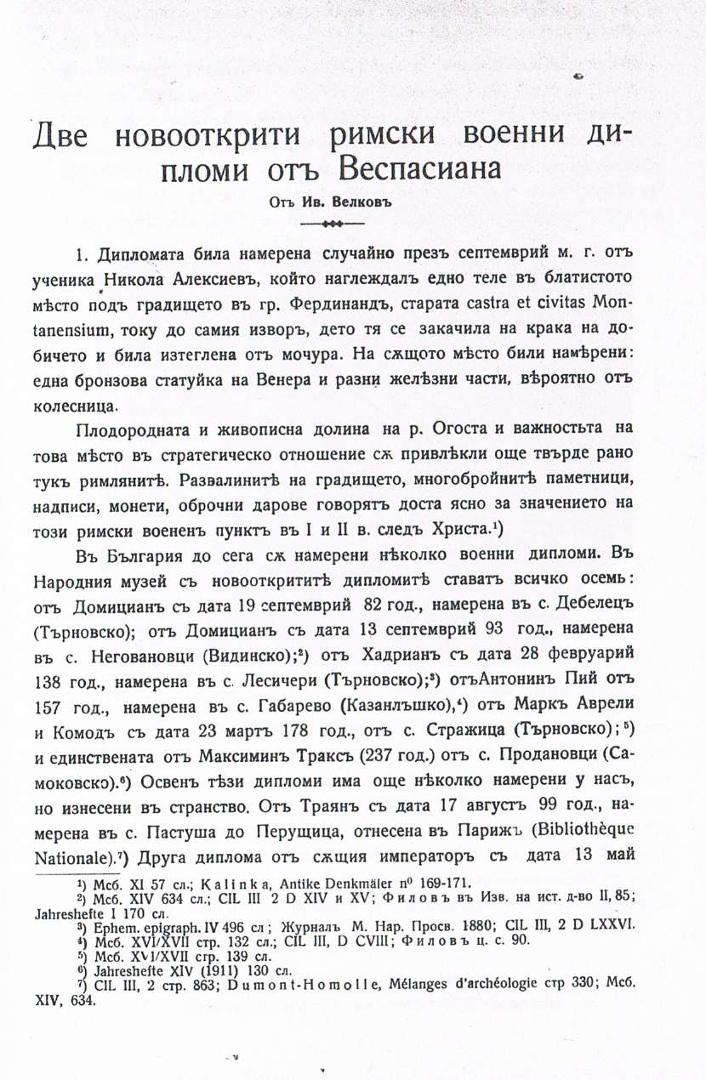

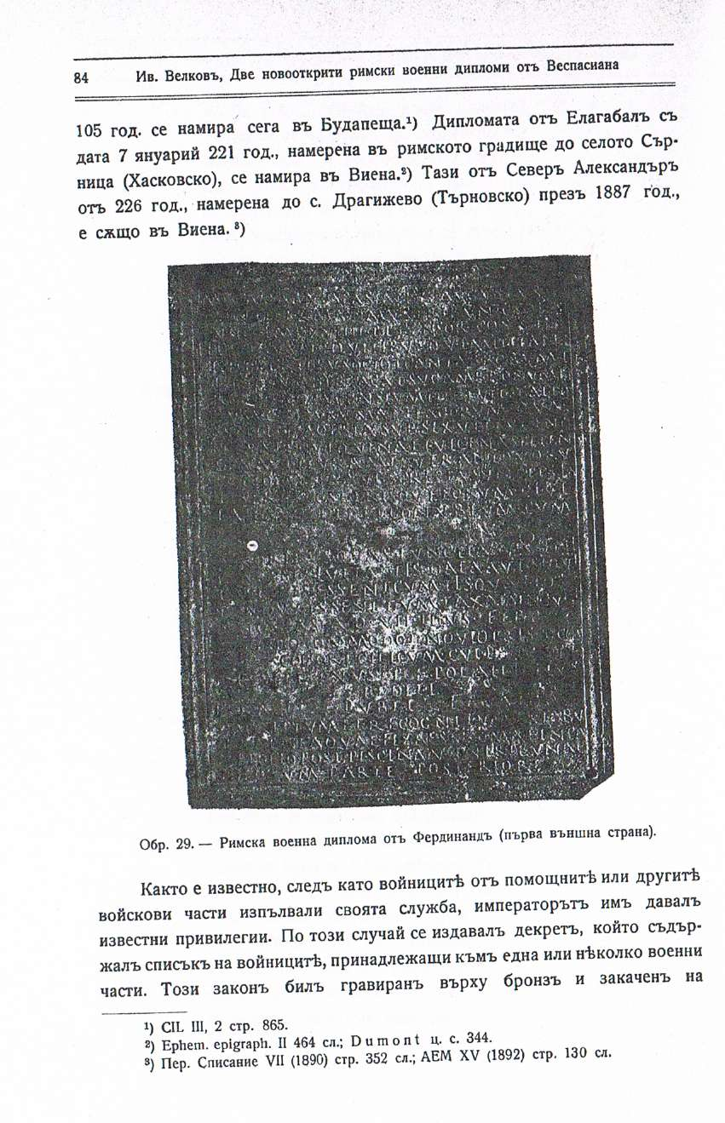

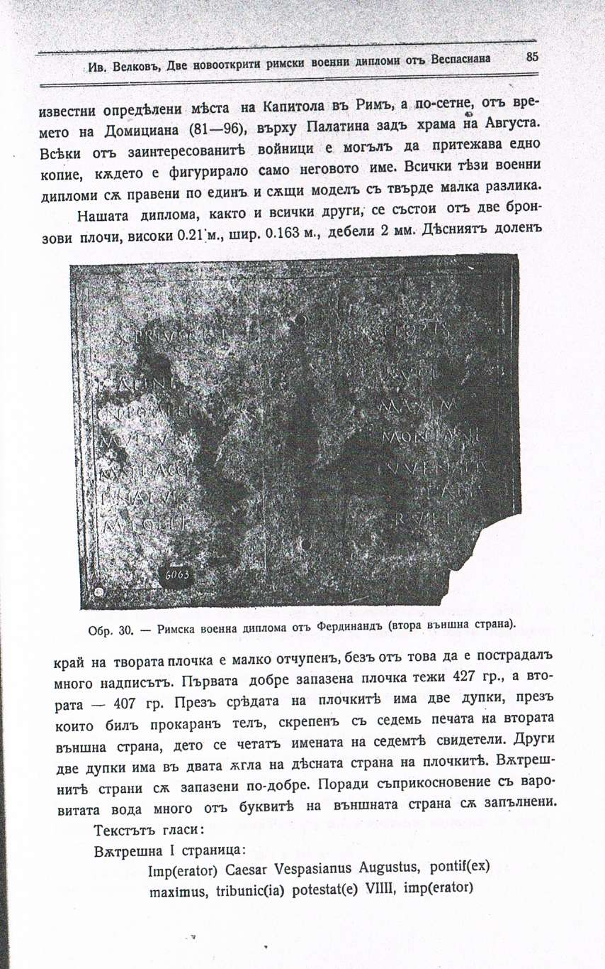

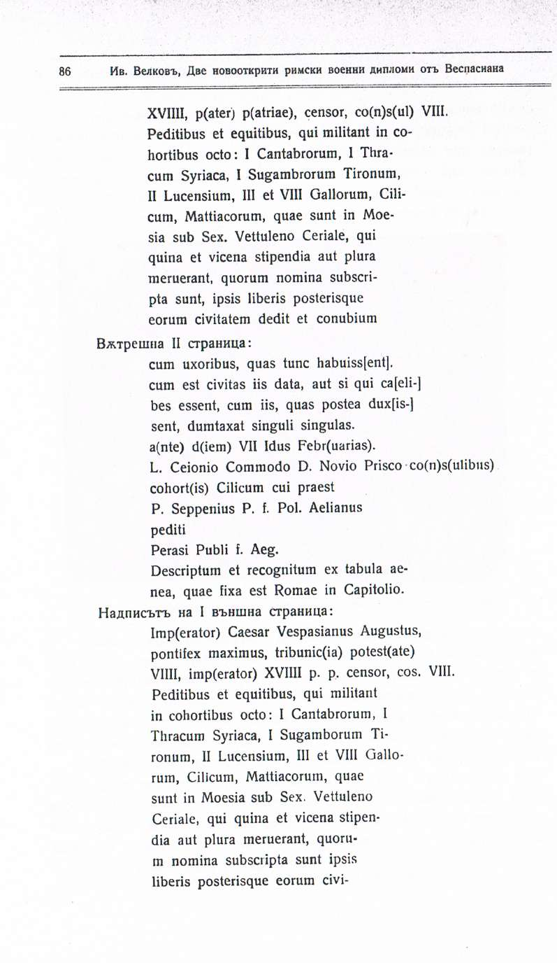

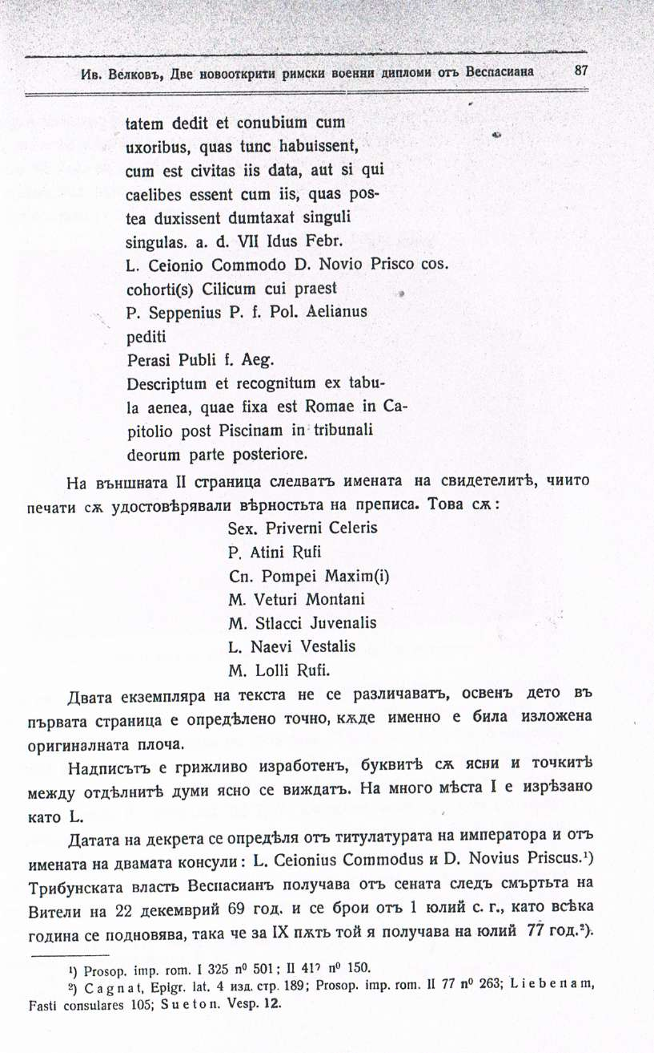

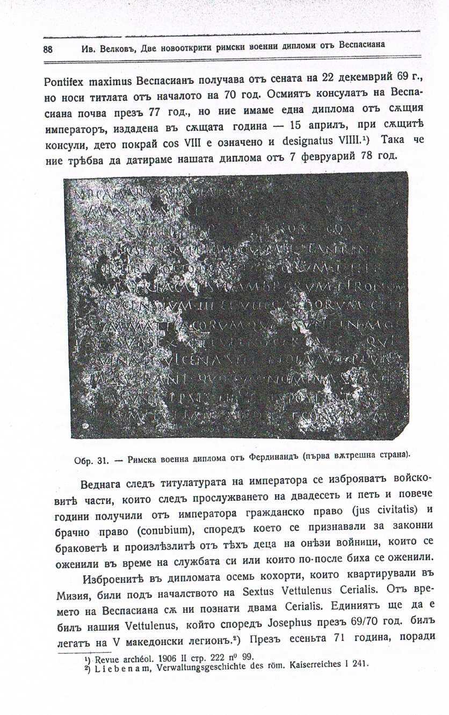

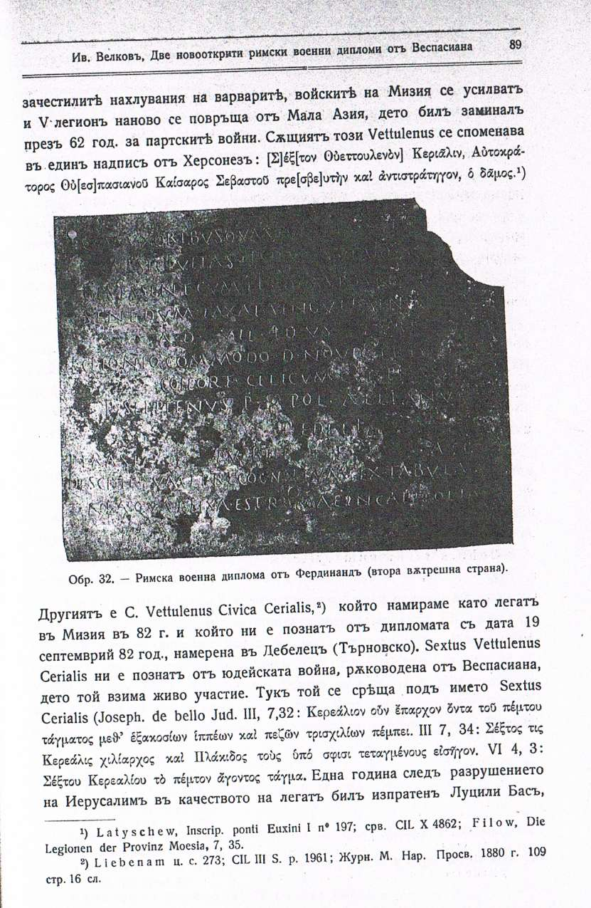

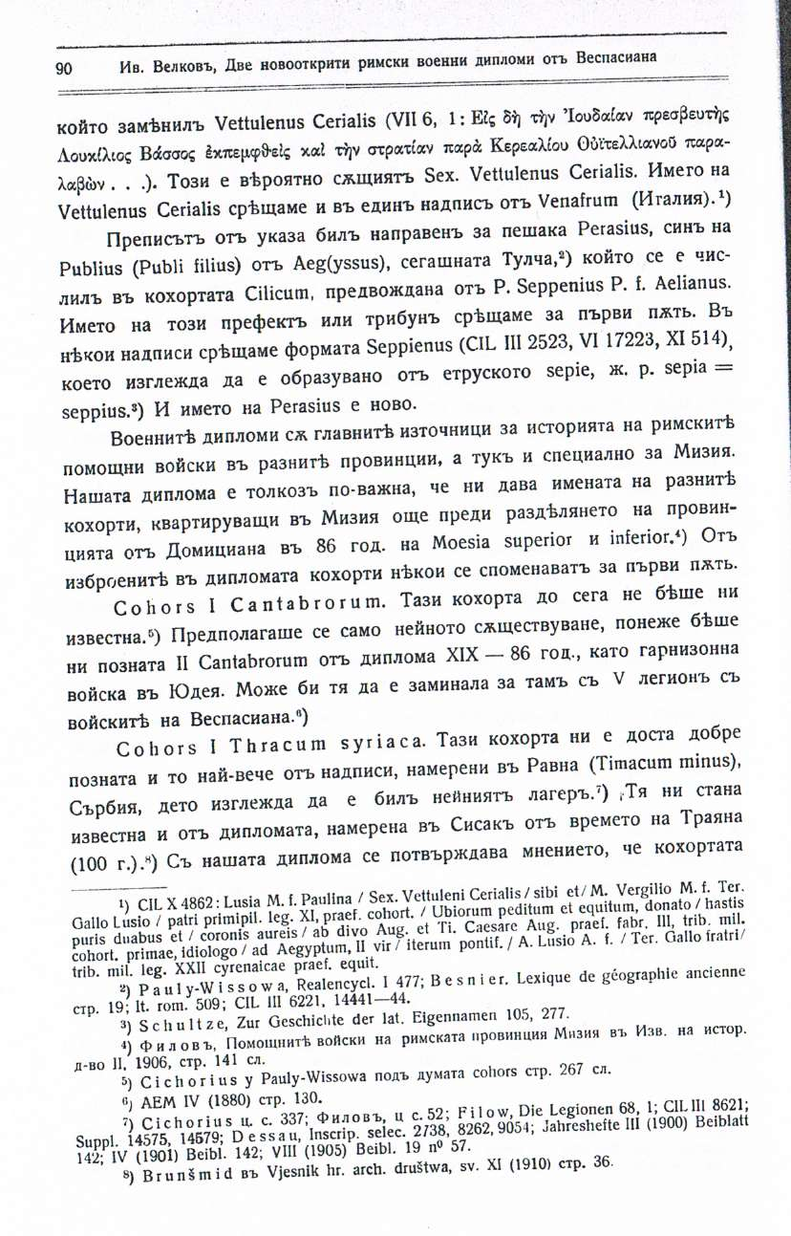

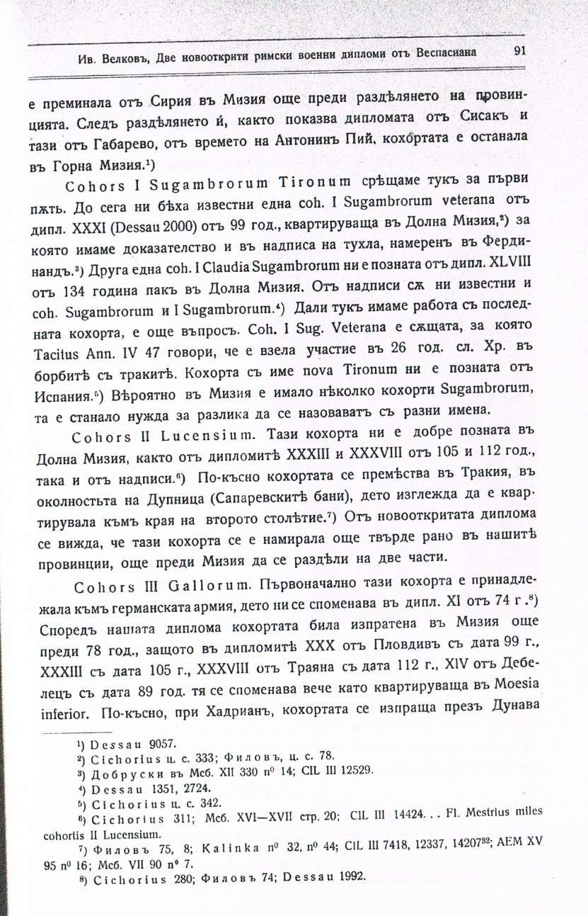

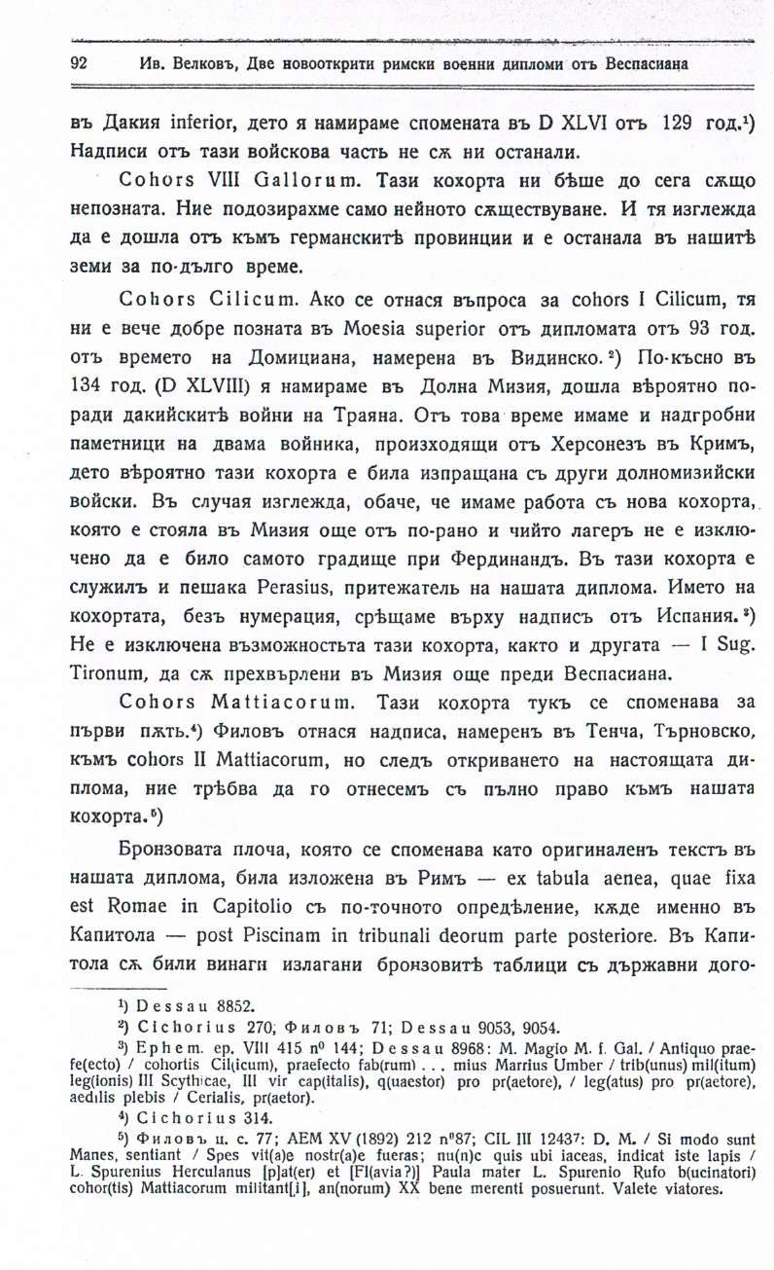

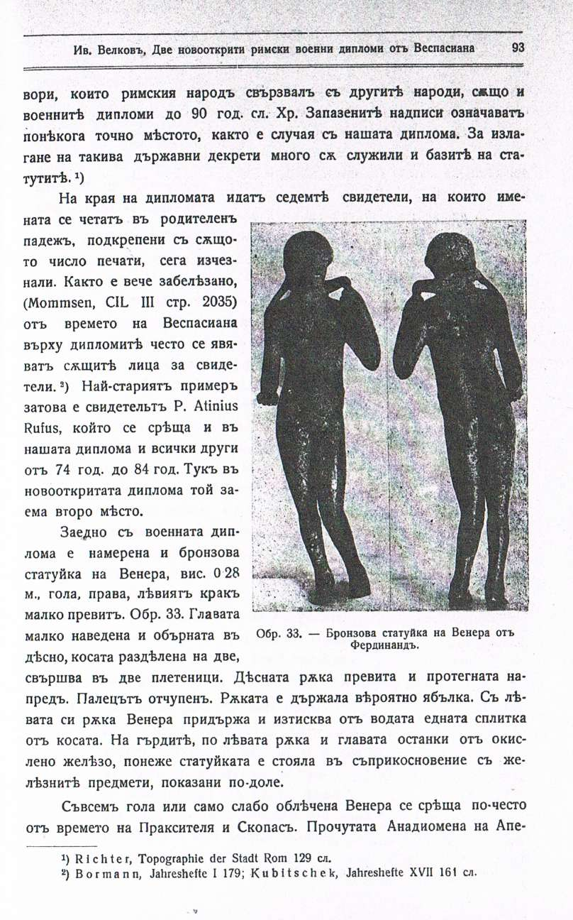

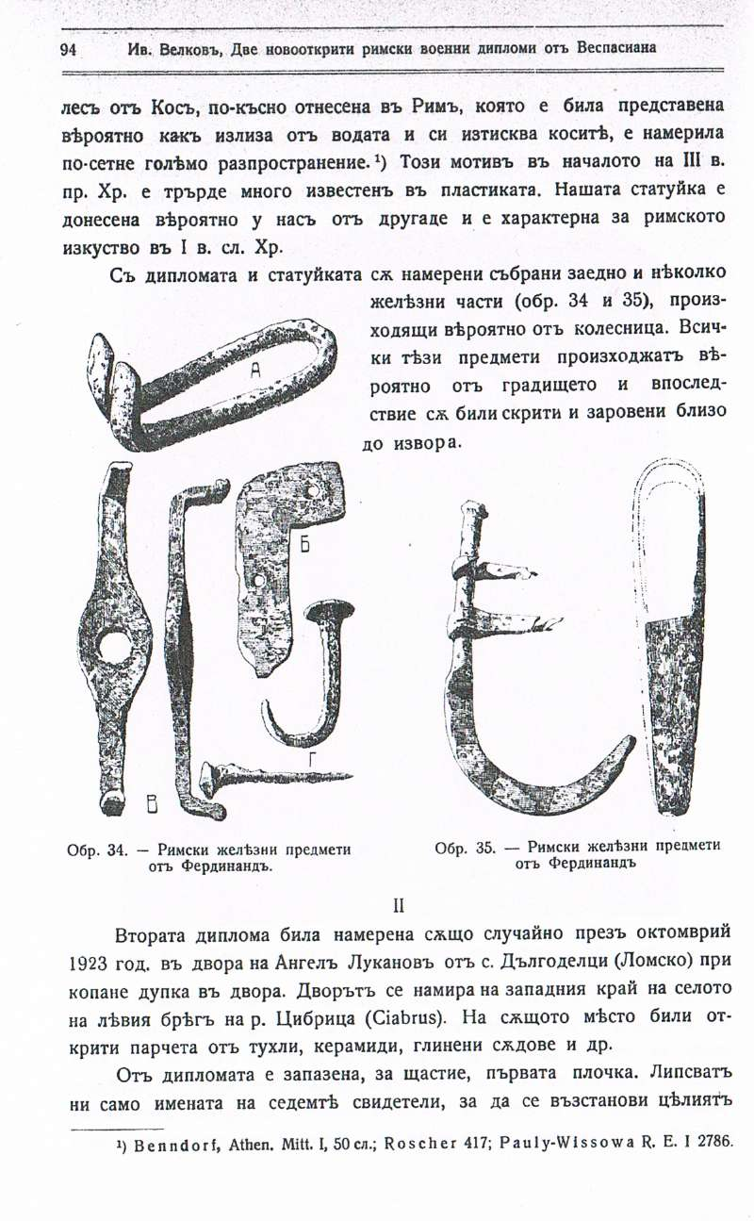

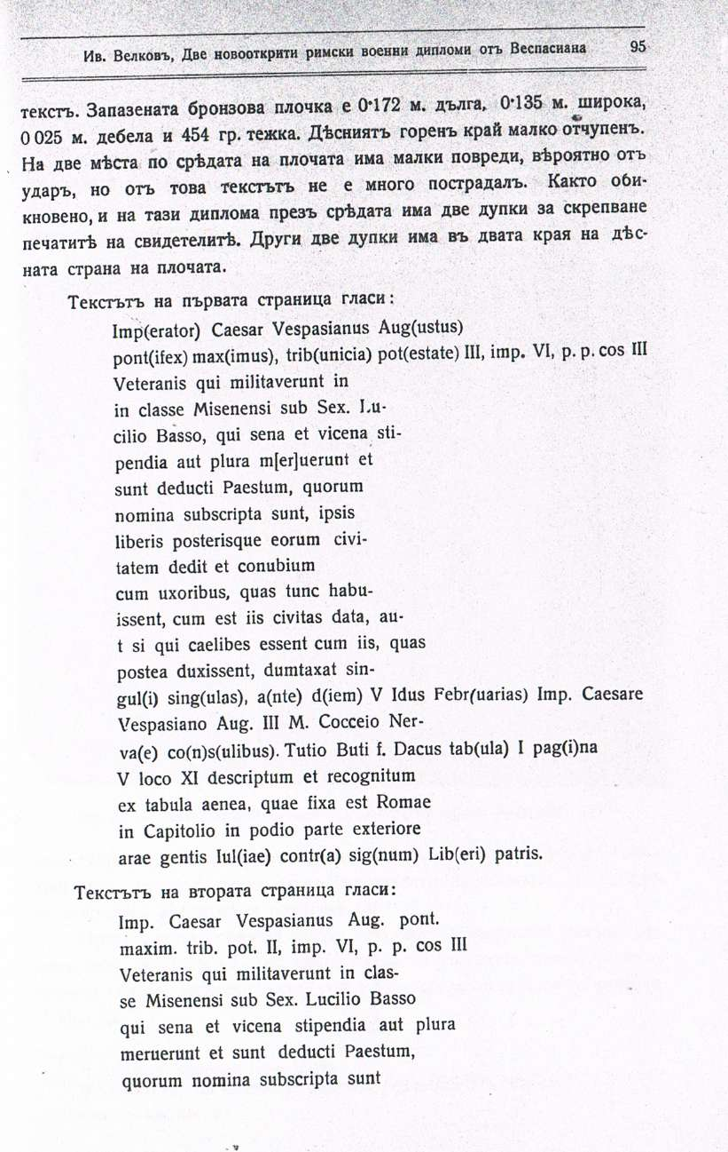

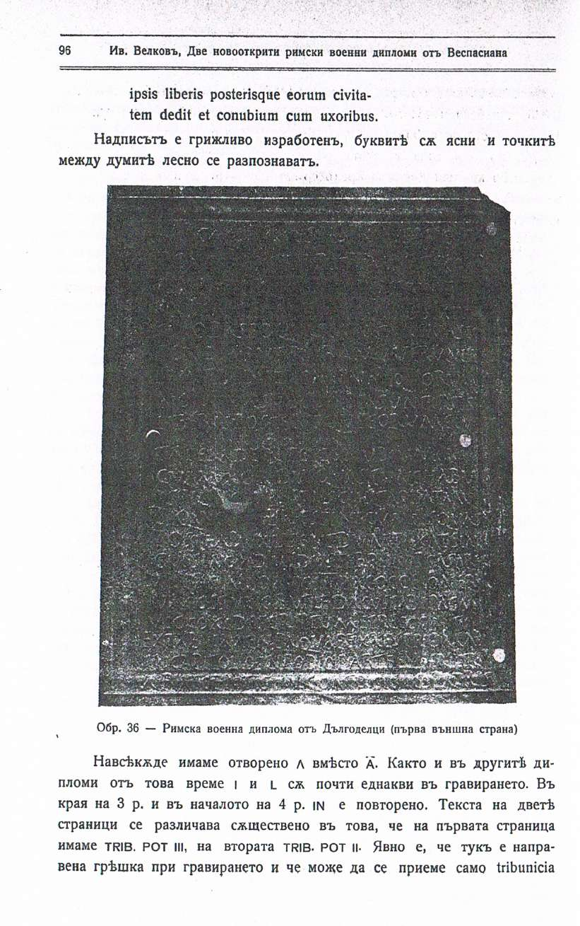

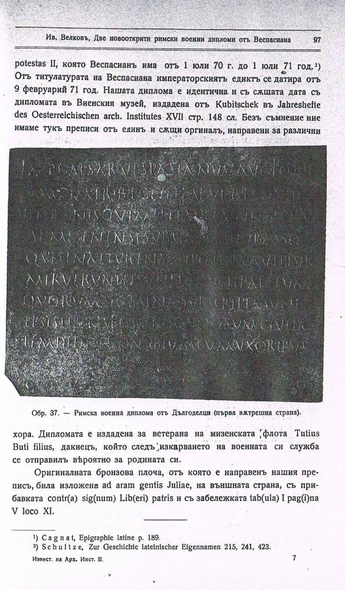

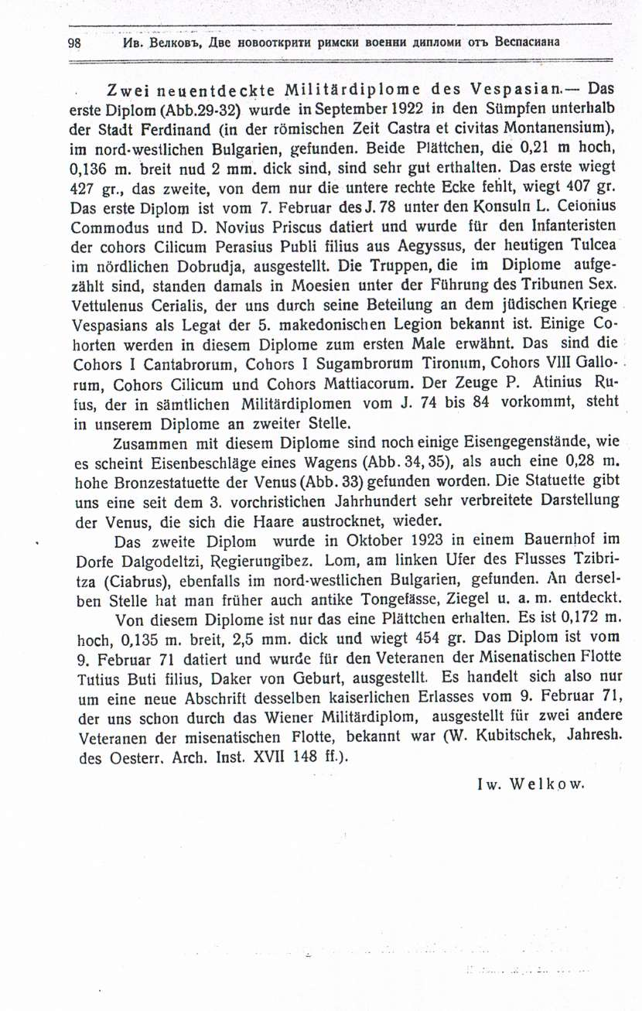

Велков, Ив. Две новооткрити римски дипломи от Веспасиана. ИАИ, ІІ, 1924, с. 83-98.

INCLUDEPICTURE "http://t0.gstatic.com/images?q=tbn:ANd9GcTDT1jpfS6n_Y4NmsXFnf0dV2uAk854tEHeOSaIXPxUCt7qxHu5xaSaZA" \* MERGEFORMATINET INCLUDEPICTURE "http://t0.gstatic.com/images?q=tbn:ANd9GcTDT1jpfS6n_Y4NmsXFnf0dV2uAk854tEHeOSaIXPxUCt7qxHu5xaSaZA" \* MERGEFORMATINET INCLUDEPICTURE "http://t0.gstatic.com/images?q=tbn:ANd9GcTDT1jpfS6n_Y4NmsXFnf0dV2uAk854tEHeOSaIXPxUCt7qxHu5xaSaZA" \* MERGEFORMATINET INCLUDEPICTURE "http://t0.gstatic.com/images?q=tbn:ANd9GcTDT1jpfS6n_Y4NmsXFnf0dV2uAk854tEHeOSaIXPxUCt7qxHu5xaSaZA" \* MERGEFORMATINET INCLUDEPICTURE "http://t0.gstatic.com/images?q=tbn:ANd9GcTDT1jpfS6n_Y4NmsXFnf0dV2uAk854tEHeOSaIXPxUCt7qxHu5xaSaZA" \* MERGEFORMATINET INCLUDEPICTURE "http://t0.gstatic.com/images?q=tbn:ANd9GcTDT1jpfS6n_Y4NmsXFnf0dV2uAk854tEHeOSaIXPxUCt7qxHu5xaSaZA" \* MERGEFORMATINET INCLUDEPICTURE "http://t0.gstatic.com/images?q=tbn:ANd9GcTDT1jpfS6n_Y4NmsXFnf0dV2uAk854tEHeOSaIXPxUCt7qxHu5xaSaZA" \* MERGEFORMATINET INCLUDEPICTURE "http://t0.gstatic.com/images?q=tbn:ANd9GcTDT1jpfS6n_Y4NmsXFnf0dV2uAk854tEHeOSaIXPxUCt7qxHu5xaSaZA" \* MERGEFORMATINET INCLUDEPICTURE "http://t0.gstatic.com/images?q=tbn:ANd9GcTDT1jpfS6n_Y4NmsXFnf0dV2uAk854tEHeOSaIXPxUCt7qxHu5xaSaZA" \* MERGEFORMATINET INCLUDEPICTURE "http://t0.gstatic.com/images?q=tbn:ANd9GcTDT1jpfS6n_Y4NmsXFnf0dV2uAk854tEHeOSaIXPxUCt7qxHu5xaSaZA" \* MERGEFORMATINET INCLUDEPICTURE "http://t0.gstatic.com/images?q=tbn:ANd9GcTDT1jpfS6n_Y4NmsXFnf0dV2uAk854tEHeOSaIXPxUCt7qxHu5xaSaZA" \* MERGEFORMATINET INCLUDEPICTURE "http://t0.gstatic.com/images?q=tbn:ANd9GcTDT1jpfS6n_Y4NmsXFnf0dV2uAk854tEHeOSaIXPxUCt7qxHu5xaSaZA" \* MERGEFORMATINET INCLUDEPICTURE "http://t0.gstatic.com/images?q=tbn:ANd9GcTDT1jpfS6n_Y4NmsXFnf0dV2uAk854tEHeOSaIXPxUCt7qxHu5xaSaZA" \* MERGEFORMATINET INCLUDEPICTURE "http://t0.gstatic.com/images?q=tbn:ANd9GcTDT1jpfS6n_Y4NmsXFnf0dV2uAk854tEHeOSaIXPxUCt7qxHu5xaSaZA" \* MERGEFORMATINET INCLUDEPICTURE "http://t0.gstatic.com/images?q=tbn:ANd9GcTDT1jpfS6n_Y4NmsXFnf0dV2uAk854tEHeOSaIXPxUCt7qxHu5xaSaZA" \* MERGEFORMATINET INCLUDEPICTURE "http://t0.gstatic.com/images?q=tbn:ANd9GcTDT1jpfS6n_Y4NmsXFnf0dV2uAk854tEHeOSaIXPxUCt7qxHu5xaSaZA" \* MERGEFORMATINET INCLUDEPICTURE "http://t0.gstatic.com/images?q=tbn:ANd9GcTDT1jpfS6n_Y4NmsXFnf0dV2uAk854tEHeOSaIXPxUCt7qxHu5xaSaZA" \* MERGEFORMATINET INCLUDEPICTURE "http://t0.gstatic.com/images?q=tbn:ANd9GcTDT1jpfS6n_Y4NmsXFnf0dV2uAk854tEHeOSaIXPxUCt7qxHu5xaSaZA" \* MERGEFORMATINET INCLUDEPICTURE "http://t0.gstatic.com/images?q=tbn:ANd9GcTDT1jpfS6n_Y4NmsXFnf0dV2uAk854tEHeOSaIXPxUCt7qxHu5xaSaZA" \* MERGEFORMATINET INCLUDEPICTURE "http://t0.gstatic.com/images?q=tbn:ANd9GcTDT1jpfS6n_Y4NmsXFnf0dV2uAk854tEHeOSaIXPxUCt7qxHu5xaSaZA" \* MERGEFORMATINET INCLUDEPICTURE "http://t0.gstatic.com/images?q=tbn:ANd9GcTDT1jpfS6n_Y4NmsXFnf0dV2uAk854tEHeOSaIXPxUCt7qxHu5xaSaZA" \* MERGEFORMATINET INCLUDEPICTURE "http://t0.gstatic.com/images?q=tbn:ANd9GcTDT1jpfS6n_Y4NmsXFnf0dV2uAk854tEHeOSaIXPxUCt7qxHu5xaSaZA" \* MERGEFORMATINET INCLUDEPICTURE "http://t0.gstatic.com/images?q=tbn:ANd9GcTDT1jpfS6n_Y4NmsXFnf0dV2uAk854tEHeOSaIXPxUCt7qxHu5xaSaZA" \* MERGEFORMATINET INCLUDEPICTURE "http://t0.gstatic.com/images?q=tbn:ANd9GcTDT1jpfS6n_Y4NmsXFnf0dV2uAk854tEHeOSaIXPxUCt7qxHu5xaSaZA" \* MERGEFORMATINET INCLUDEPICTURE "http://t0.gstatic.com/images?q=tbn:ANd9GcTDT1jpfS6n_Y4NmsXFnf0dV2uAk854tEHeOSaIXPxUCt7qxHu5xaSaZA" \* MERGEFORMATINET INCLUDEPICTURE "http://t0.gstatic.com/images?q=tbn:ANd9GcTDT1jpfS6n_Y4NmsXFnf0dV2uAk854tEHeOSaIXPxUCt7qxHu5xaSaZA" \* MERGEFORMATINET INCLUDEPICTURE "http://t0.gstatic.com/images?q=tbn:ANd9GcTDT1jpfS6n_Y4NmsXFnf0dV2uAk854tEHeOSaIXPxUCt7qxHu5xaSaZA" \* MERGEFORMATINET INCLUDEPICTURE "http://t0.gstatic.com/images?q=tbn:ANd9GcTDT1jpfS6n_Y4NmsXFnf0dV2uAk854tEHeOSaIXPxUCt7qxHu5xaSaZA" \* MERGEFORMATINET INCLUDEPICTURE "http://t0.gstatic.com/images?q=tbn:ANd9GcTDT1jpfS6n_Y4NmsXFnf0dV2uAk854tEHeOSaIXPxUCt7qxHu5xaSaZA" \* MERGEFORMATINET INCLUDEPICTURE "http://t0.gstatic.com/images?q=tbn:ANd9GcTDT1jpfS6n_Y4NmsXFnf0dV2uAk854tEHeOSaIXPxUCt7qxHu5xaSaZA" \* MERGEFORMATINET INCLUDEPICTURE "http://t0.gstatic.com/images?q=tbn:ANd9GcTDT1jpfS6n_Y4NmsXFnf0dV2uAk854tEHeOSaIXPxUCt7qxHu5xaSaZA" \* MERGEFORMATINET INCLUDEPICTURE "http://t0.gstatic.com/images?q=tbn:ANd9GcTDT1jpfS6n_Y4NmsXFnf0dV2uAk854tEHeOSaIXPxUCt7qxHu5xaSaZA" \* MERGEFORMATINET INCLUDEPICTURE "http://t0.gstatic.com/images?q=tbn:ANd9GcTDT1jpfS6n_Y4NmsXFnf0dV2uAk854tEHeOSaIXPxUCt7qxHu5xaSaZA" \* MERGEFORMATINET INCLUDEPICTURE "http://t0.gstatic.com/images?q=tbn:ANd9GcTDT1jpfS6n_Y4NmsXFnf0dV2uAk854tEHeOSaIXPxUCt7qxHu5xaSaZA" \* MERGEFORMATINET INCLUDEPICTURE "http://t0.gstatic.com/images?q=tbn:ANd9GcTDT1jpfS6n_Y4NmsXFnf0dV2uAk854tEHeOSaIXPxUCt7qxHu5xaSaZA" \* MERGEFORMATINET INCLUDEPICTURE "http://t0.gstatic.com/images?q=tbn:ANd9GcTDT1jpfS6n_Y4NmsXFnf0dV2uAk854tEHeOSaIXPxUCt7qxHu5xaSaZA" \* MERGEFORMATINET INCLUDEPICTURE "http://t0.gstatic.com/images?q=tbn:ANd9GcTDT1jpfS6n_Y4NmsXFnf0dV2uAk854tEHeOSaIXPxUCt7qxHu5xaSaZA" \* MERGEFORMATINET INCLUDEPICTURE "http://t0.gstatic.com/images?q=tbn:ANd9GcTDT1jpfS6n_Y4NmsXFnf0dV2uAk854tEHeOSaIXPxUCt7qxHu5xaSaZA" \* MERGEFORMATINET INCLUDEPICTURE "http://t0.gstatic.com/images?q=tbn:ANd9GcTDT1jpfS6n_Y4NmsXFnf0dV2uAk854tEHeOSaIXPxUCt7qxHu5xaSaZA" \* MERGEFORMATINET INCLUDEPICTURE "http://t0.gstatic.com/images?q=tbn:ANd9GcTDT1jpfS6n_Y4NmsXFnf0dV2uAk854tEHeOSaIXPxUCt7qxHu5xaSaZA" \* MERGEFORMATINET INCLUDEPICTURE "http://t0.gstatic.com/images?q=tbn:ANd9GcTDT1jpfS6n_Y4NmsXFnf0dV2uAk854tEHeOSaIXPxUCt7qxHu5xaSaZA" \* MERGEFORMATINET INCLUDEPICTURE "http://t0.gstatic.com/images?q=tbn:ANd9GcTDT1jpfS6n_Y4NmsXFnf0dV2uAk854tEHeOSaIXPxUCt7qxHu5xaSaZA" \* MERGEFORMATINET INCLUDEPICTURE "http://t0.gstatic.com/images?q=tbn:ANd9GcTDT1jpfS6n_Y4NmsXFnf0dV2uAk854tEHeOSaIXPxUCt7qxHu5xaSaZA" \* MERGEFORMATINET INCLUDEPICTURE "http://t0.gstatic.com/images?q=tbn:ANd9GcTDT1jpfS6n_Y4NmsXFnf0dV2uAk854tEHeOSaIXPxUCt7qxHu5xaSaZA" \* MERGEFORMATINET INCLUDEPICTURE "http://t0.gstatic.com/images?q=tbn:ANd9GcTDT1jpfS6n_Y4NmsXFnf0dV2uAk854tEHeOSaIXPxUCt7qxHu5xaSaZA" \* MERGEFORMATINET INCLUDEPICTURE "http://t0.gstatic.com/images?q=tbn:ANd9GcTDT1jpfS6n_Y4NmsXFnf0dV2uAk854tEHeOSaIXPxUCt7qxHu5xaSaZA" \* MERGEFORMATINET INCLUDEPICTURE "http://t0.gstatic.com/images?q=tbn:ANd9GcTDT1jpfS6n_Y4NmsXFnf0dV2uAk854tEHeOSaIXPxUCt7qxHu5xaSaZA" \* MERGEFORMATINET INCLUDEPICTURE "http://t0.gstatic.com/images?q=tbn:ANd9GcTDT1jpfS6n_Y4NmsXFnf0dV2uAk854tEHeOSaIXPxUCt7qxHu5xaSaZA" \* MERGEFORMATINET INCLUDEPICTURE "http://t0.gstatic.com/images?q=tbn:ANd9GcTDT1jpfS6n_Y4NmsXFnf0dV2uAk854tEHeOSaIXPxUCt7qxHu5xaSaZA" \* MERGEFORMATINET INCLUDEPICTURE "http://t0.gstatic.com/images?q=tbn:ANd9GcTDT1jpfS6n_Y4NmsXFnf0dV2uAk854tEHeOSaIXPxUCt7qxHu5xaSaZA" \* MERGEFORMATINET INCLUDEPICTURE "http://t0.gstatic.com/images?q=tbn:ANd9GcTDT1jpfS6n_Y4NmsXFnf0dV2uAk854tEHeOSaIXPxUCt7qxHu5xaSaZA" \* MERGEFORMATINET INCLUDEPICTURE "http://t0.gstatic.com/images?q=tbn:ANd9GcTDT1jpfS6n_Y4NmsXFnf0dV2uAk854tEHeOSaIXPxUCt7qxHu5xaSaZA" \* MERGEFORMATINET INCLUDEPICTURE "http://t0.gstatic.com/images?q=tbn:ANd9GcTDT1jpfS6n_Y4NmsXFnf0dV2uAk854tEHeOSaIXPxUCt7qxHu5xaSaZA" \* MERGEFORMATINET INCLUDEPICTURE "http://t0.gstatic.com/images?q=tbn:ANd9GcTDT1jpfS6n_Y4NmsXFnf0dV2uAk854tEHeOSaIXPxUCt7qxHu5xaSaZA" \* MERGEFORMATINET INCLUDEPICTURE "http://t0.gstatic.com/images?q=tbn:ANd9GcTDT1jpfS6n_Y4NmsXFnf0dV2uAk854tEHeOSaIXPxUCt7qxHu5xaSaZA" \* MERGEFORMATINET INCLUDEPICTURE "http://t0.gstatic.com/images?q=tbn:ANd9GcTDT1jpfS6n_Y4NmsXFnf0dV2uAk854tEHeOSaIXPxUCt7qxHu5xaSaZA" \* MERGEFORMATINET INCLUDEPICTURE "http://t0.gstatic.com/images?q=tbn:ANd9GcTDT1jpfS6n_Y4NmsXFnf0dV2uAk854tEHeOSaIXPxUCt7qxHu5xaSaZA" \* MERGEFORMATINET INCLUDEPICTURE "http://t0.gstatic.com/images?q=tbn:ANd9GcTDT1jpfS6n_Y4NmsXFnf0dV2uAk854tEHeOSaIXPxUCt7qxHu5xaSaZA" \* MERGEFORMATINET INCLUDEPICTURE "http://t0.gstatic.com/images?q=tbn:ANd9GcTDT1jpfS6n_Y4NmsXFnf0dV2uAk854tEHeOSaIXPxUCt7qxHu5xaSaZA" \* MERGEFORMATINET INCLUDEPICTURE "http://t0.gstatic.com/images?q=tbn:ANd9GcTDT1jpfS6n_Y4NmsXFnf0dV2uAk854tEHeOSaIXPxUCt7qxHu5xaSaZA" \* MERGEFORMATINET INCLUDEPICTURE "http://t0.gstatic.com/images?q=tbn:ANd9GcTDT1jpfS6n_Y4NmsXFnf0dV2uAk854tEHeOSaIXPxUCt7qxHu5xaSaZA" \* MERGEFORMATINET INCLUDEPICTURE "http://t0.gstatic.com/images?q=tbn:ANd9GcTDT1jpfS6n_Y4NmsXFnf0dV2uAk854tEHeOSaIXPxUCt7qxHu5xaSaZA" \* MERGEFORMATINET INCLUDEPICTURE "http://t0.gstatic.com/images?q=tbn:ANd9GcTDT1jpfS6n_Y4NmsXFnf0dV2uAk854tEHeOSaIXPxUCt7qxHu5xaSaZA" \* MERGEFORMATINET INCLUDEPICTURE "http://t0.gstatic.com/images?q=tbn:ANd9GcTDT1jpfS6n_Y4NmsXFnf0dV2uAk854tEHeOSaIXPxUCt7qxHu5xaSaZA" \* MERGEFORMATINET INCLUDEPICTURE "http://t0.gstatic.com/images?q=tbn:ANd9GcTDT1jpfS6n_Y4NmsXFnf0dV2uAk854tEHeOSaIXPxUCt7qxHu5xaSaZA" \* MERGEFORMATINET INCLUDEPICTURE "http://t0.gstatic.com/images?q=tbn:ANd9GcTDT1jpfS6n_Y4NmsXFnf0dV2uAk854tEHeOSaIXPxUCt7qxHu5xaSaZA" \* MERGEFORMATINET INCLUDEPICTURE "http://t0.gstatic.com/images?q=tbn:ANd9GcTDT1jpfS6n_Y4NmsXFnf0dV2uAk854tEHeOSaIXPxUCt7qxHu5xaSaZA" \* MERGEFORMATINET INCLUDEPICTURE "http://t0.gstatic.com/images?q=tbn:ANd9GcTDT1jpfS6n_Y4NmsXFnf0dV2uAk854tEHeOSaIXPxUCt7qxHu5xaSaZA" \* MERGEFORMATINET INCLUDEPICTURE "http://t0.gstatic.com/images?q=tbn:ANd9GcTDT1jpfS6n_Y4NmsXFnf0dV2uAk854tEHeOSaIXPxUCt7qxHu5xaSaZA" \* MERGEFORMATINET INCLUDEPICTURE "http://t0.gstatic.com/images?q=tbn:ANd9GcTDT1jpfS6n_Y4NmsXFnf0dV2uAk854tEHeOSaIXPxUCt7qxHu5xaSaZA" \* MERGEFORMATINET INCLUDEPICTURE "http://t0.gstatic.com/images?q=tbn:ANd9GcTDT1jpfS6n_Y4NmsXFnf0dV2uAk854tEHeOSaIXPxUCt7qxHu5xaSaZA" \* MERGEFORMATINET INCLUDEPICTURE "http://t0.gstatic.com/images?q=tbn:ANd9GcTDT1jpfS6n_Y4NmsXFnf0dV2uAk854tEHeOSaIXPxUCt7qxHu5xaSaZA" \* MERGEFORMATINET INCLUDEPICTURE "http://t0.gstatic.com/images?q=tbn:ANd9GcTDT1jpfS6n_Y4NmsXFnf0dV2uAk854tEHeOSaIXPxUCt7qxHu5xaSaZA" \* MERGEFORMATINET INCLUDEPICTURE "http://t0.gstatic.com/images?q=tbn:ANd9GcTDT1jpfS6n_Y4NmsXFnf0dV2uAk854tEHeOSaIXPxUCt7qxHu5xaSaZA" \* MERGEFORMATINET INCLUDEPICTURE "http://t0.gstatic.com/images?q=tbn:ANd9GcTDT1jpfS6n_Y4NmsXFnf0dV2uAk854tEHeOSaIXPxUCt7qxHu5xaSaZA" \* MERGEFORMATINET INCLUDEPICTURE "http://t0.gstatic.com/images?q=tbn:ANd9GcTDT1jpfS6n_Y4NmsXFnf0dV2uAk854tEHeOSaIXPxUCt7qxHu5xaSaZA" \* MERGEFORMATINET INCLUDEPICTURE "http://t0.gstatic.com/images?q=tbn:ANd9GcTDT1jpfS6n_Y4NmsXFnf0dV2uAk854tEHeOSaIXPxUCt7qxHu5xaSaZA" \* MERGEFORMATINET INCLUDEPICTURE "http://t0.gstatic.com/images?q=tbn:ANd9GcTDT1jpfS6n_Y4NmsXFnf0dV2uAk854tEHeOSaIXPxUCt7qxHu5xaSaZA" \* MERGEFORMATINET INCLUDEPICTURE "http://t0.gstatic.com/images?q=tbn:ANd9GcTDT1jpfS6n_Y4NmsXFnf0dV2uAk854tEHeOSaIXPxUCt7qxHu5xaSaZA" \* MERGEFORMATINET INCLUDEPICTURE "http://t0.gstatic.com/images?q=tbn:ANd9GcTDT1jpfS6n_Y4NmsXFnf0dV2uAk854tEHeOSaIXPxUCt7qxHu5xaSaZA" \* MERGEFORMATINET INCLUDEPICTURE "http://t0.gstatic.com/images?q=tbn:ANd9GcTDT1jpfS6n_Y4NmsXFnf0dV2uAk854tEHeOSaIXPxUCt7qxHu5xaSaZA" \* MERGEFORMATINET INCLUDEPICTURE "http://t0.gstatic.com/images?q=tbn:ANd9GcTDT1jpfS6n_Y4NmsXFnf0dV2uAk854tEHeOSaIXPxUCt7qxHu5xaSaZA" \* MERGEFORMATINET INCLUDEPICTURE "http://t0.gstatic.com/images?q=tbn:ANd9GcTDT1jpfS6n_Y4NmsXFnf0dV2uAk854tEHeOSaIXPxUCt7qxHu5xaSaZA" \* MERGEFORMATINET INCLUDEPICTURE "http://t0.gstatic.com/images?q=tbn:ANd9GcTDT1jpfS6n_Y4NmsXFnf0dV2uAk854tEHeOSaIXPxUCt7qxHu5xaSaZA" \* MERGEFORMATINET INCLUDEPICTURE "http://t0.gstatic.com/images?q=tbn:ANd9GcTDT1jpfS6n_Y4NmsXFnf0dV2uAk854tEHeOSaIXPxUCt7qxHu5xaSaZA" \* MERGEFORMATINET INCLUDEPICTURE "http://t0.gstatic.com/images?q=tbn:ANd9GcTDT1jpfS6n_Y4NmsXFnf0dV2uAk854tEHeOSaIXPxUCt7qxHu5xaSaZA" \* MERGEFORMATINET INCLUDEPICTURE "http://t0.gstatic.com/images?q=tbn:ANd9GcTDT1jpfS6n_Y4NmsXFnf0dV2uAk854tEHeOSaIXPxUCt7qxHu5xaSaZA" \* MERGEFORMATINET INCLUDEPICTURE "http://t0.gstatic.com/images?q=tbn:ANd9GcTDT1jpfS6n_Y4NmsXFnf0dV2uAk854tEHeOSaIXPxUCt7qxHu5xaSaZA" \* MERGEFORMATINET INCLUDEPICTURE "http://t0.gstatic.com/images?q=tbn:ANd9GcTDT1jpfS6n_Y4NmsXFnf0dV2uAk854tEHeOSaIXPxUCt7qxHu5xaSaZA" \* MERGEFORMATINET INCLUDEPICTURE "http://t0.gstatic.com/images?q=tbn:ANd9GcTDT1jpfS6n_Y4NmsXFnf0dV2uAk854tEHeOSaIXPxUCt7qxHu5xaSaZA" \* MERGEFORMATINET INCLUDEPICTURE "http://t0.gstatic.com/images?q=tbn:ANd9GcTDT1jpfS6n_Y4NmsXFnf0dV2uAk854tEHeOSaIXPxUCt7qxHu5xaSaZA" \* MERGEFORMATINET INCLUDEPICTURE "http://t0.gstatic.com/images?q=tbn:ANd9GcTDT1jpfS6n_Y4NmsXFnf0dV2uAk854tEHeOSaIXPxUCt7qxHu5xaSaZA" \* MERGEFORMATINET INCLUDEPICTURE "http://t0.gstatic.com/images?q=tbn:ANd9GcTDT1jpfS6n_Y4NmsXFnf0dV2uAk854tEHeOSaIXPxUCt7qxHu5xaSaZA" \* MERGEFORMATINET INCLUDEPICTURE "http://t0.gstatic.com/images?q=tbn:ANd9GcTDT1jpfS6n_Y4NmsXFnf0dV2uAk854tEHeOSaIXPxUCt7qxHu5xaSaZA" \* MERGEFORMATINET INCLUDEPICTURE "http://t0.gstatic.com/images?q=tbn:ANd9GcTDT1jpfS6n_Y4NmsXFnf0dV2uAk854tEHeOSaIXPxUCt7qxHu5xaSaZA" \* MERGEFORMATINET INCLUDEPICTURE "http://t0.gstatic.com/images?q=tbn:ANd9GcTDT1jpfS6n_Y4NmsXFnf0dV2uAk854tEHeOSaIXPxUCt7qxHu5xaSaZA" \* MERGEFORMATINET INCLUDEPICTURE "http://t0.gstatic.com/images?q=tbn:ANd9GcTDT1jpfS6n_Y4NmsXFnf0dV2uAk854tEHeOSaIXPxUCt7qxHu5xaSaZA" \* MERGEFORMATINET INCLUDEPICTURE "http://t0.gstatic.com/images?q=tbn:ANd9GcTDT1jpfS6n_Y4NmsXFnf0dV2uAk854tEHeOSaIXPxUCt7qxHu5xaSaZA" \* MERGEFORMATINET INCLUDEPICTURE "http://t0.gstatic.com/images?q=tbn:ANd9GcTDT1jpfS6n_Y4NmsXFnf0dV2uAk854tEHeOSaIXPxUCt7qxHu5xaSaZA" \* MERGEFORMATINET INCLUDEPICTURE "http://t0.gstatic.com/images?q=tbn:ANd9GcTDT1jpfS6n_Y4NmsXFnf0dV2uAk854tEHeOSaIXPxUCt7qxHu5xaSaZA" \* MERGEFORMATINET INCLUDEPICTURE "http://t0.gstatic.com/images?q=tbn:ANd9GcTDT1jpfS6n_Y4NmsXFnf0dV2uAk854tEHeOSaIXPxUCt7qxHu5xaSaZA" \* MERGEFORMATINET INCLUDEPICTURE "http://t0.gstatic.com/images?q=tbn:ANd9GcTDT1jpfS6n_Y4NmsXFnf0dV2uAk854tEHeOSaIXPxUCt7qxHu5xaSaZA" \* MERGEFORMATINET INCLUDEPICTURE "http://t0.gstatic.com/images?q=tbn:ANd9GcTDT1jpfS6n_Y4NmsXFnf0dV2uAk854tEHeOSaIXPxUCt7qxHu5xaSaZA" \* MERGEFORMATINET INCLUDEPICTURE "http://t0.gstatic.com/images?q=tbn:ANd9GcTDT1jpfS6n_Y4NmsXFnf0dV2uAk854tEHeOSaIXPxUCt7qxHu5xaSaZA" \* MERGEFORMATINET INCLUDEPICTURE "http://t0.gstatic.com/images?q=tbn:ANd9GcTDT1jpfS6n_Y4NmsXFnf0dV2uAk854tEHeOSaIXPxUCt7qxHu5xaSaZA" \* MERGEFORMATINET INCLUDEPICTURE "http://t0.gstatic.com/images?q=tbn:ANd9GcTDT1jpfS6n_Y4NmsXFnf0dV2uAk854tEHeOSaIXPxUCt7qxHu5xaSaZA" \* MERGEFORMATINET INCLUDEPICTURE "http://t0.gstatic.com/images?q=tbn:ANd9GcTDT1jpfS6n_Y4NmsXFnf0dV2uAk854tEHeOSaIXPxUCt7qxHu5xaSaZA" \* MERGEFORMATINET INCLUDEPICTURE "http://t0.gstatic.com/images?q=tbn:ANd9GcTDT1jpfS6n_Y4NmsXFnf0dV2uAk854tEHeOSaIXPxUCt7qxHu5xaSaZA" \* MERGEFORMATINET INCLUDEPICTURE "http://t0.gstatic.com/images?q=tbn:ANd9GcTDT1jpfS6n_Y4NmsXFnf0dV2uAk854tEHeOSaIXPxUCt7qxHu5xaSaZA" \* MERGEFORMATINET INCLUDEPICTURE "http://t0.gstatic.com/images?q=tbn:ANd9GcTDT1jpfS6n_Y4NmsXFnf0dV2uAk854tEHeOSaIXPxUCt7qxHu5xaSaZA" \* MERGEFORMATINET INCLUDEPICTURE "http://t0.gstatic.com/images?q=tbn:ANd9GcTDT1jpfS6n_Y4NmsXFnf0dV2uAk854tEHeOSaIXPxUCt7qxHu5xaSaZA" \* MERGEFORMATINET INCLUDEPICTURE "http://t0.gstatic.com/images?q=tbn:ANd9GcTDT1jpfS6n_Y4NmsXFnf0dV2uAk854tEHeOSaIXPxUCt7qxHu5xaSaZA" \* MERGEFORMATINET INCLUDEPICTURE "http://t0.gstatic.com/images?q=tbn:ANd9GcTDT1jpfS6n_Y4NmsXFnf0dV2uAk854tEHeOSaIXPxUCt7qxHu5xaSaZA" \* MERGEFORMATINET INCLUDEPICTURE "http://t0.gstatic.com/images?q=tbn:ANd9GcTDT1jpfS6n_Y4NmsXFnf0dV2uAk854tEHeOSaIXPxUCt7qxHu5xaSaZA" \* MERGEFORMATINET INCLUDEPICTURE "http://t0.gstatic.com/images?q=tbn:ANd9GcTDT1jpfS6n_Y4NmsXFnf0dV2uAk854tEHeOSaIXPxUCt7qxHu5xaSaZA" \* MERGEFORMATINET INCLUDEPICTURE "http://t0.gstatic.com/images?q=tbn:ANd9GcTDT1jpfS6n_Y4NmsXFnf0dV2uAk854tEHeOSaIXPxUCt7qxHu5xaSaZA" \* MERGEFORMATINET INCLUDEPICTURE "http://t0.gstatic.com/images?q=tbn:ANd9GcTDT1jpfS6n_Y4NmsXFnf0dV2uAk854tEHeOSaIXPxUCt7qxHu5xaSaZA" \* MERGEFORMATINET INCLUDEPICTURE "http://t0.gstatic.com/images?q=tbn:ANd9GcTDT1jpfS6n_Y4NmsXFnf0dV2uAk854tEHeOSaIXPxUCt7qxHu5xaSaZA" \* MERGEFORMATINET INCLUDEPICTURE "http://t0.gstatic.com/images?q=tbn:ANd9GcTDT1jpfS6n_Y4NmsXFnf0dV2uAk854tEHeOSaIXPxUCt7qxHu5xaSaZA" \* MERGEFORMATINET INCLUDEPICTURE "http://t0.gstatic.com/images?q=tbn:ANd9GcTDT1jpfS6n_Y4NmsXFnf0dV2uAk854tEHeOSaIXPxUCt7qxHu5xaSaZA" \* MERGEFORMATINET INCLUDEPICTURE "http://t0.gstatic.com/images?q=tbn:ANd9GcTDT1jpfS6n_Y4NmsXFnf0dV2uAk854tEHeOSaIXPxUCt7qxHu5xaSaZA" \* MERGEFORMATINET INCLUDEPICTURE "http://t0.gstatic.com/images?q=tbn:ANd9GcTDT1jpfS6n_Y4NmsXFnf0dV2uAk854tEHeOSaIXPxUCt7qxHu5xaSaZA" \* MERGEFORMATINET INCLUDEPICTURE "http://t0.gstatic.com/images?q=tbn:ANd9GcTDT1jpfS6n_Y4NmsXFnf0dV2uAk854tEHeOSaIXPxUCt7qxHu5xaSaZA" \* MERGEFORMATINET INCLUDEPICTURE "http://t0.gstatic.com/images?q=tbn:ANd9GcTDT1jpfS6n_Y4NmsXFnf0dV2uAk854tEHeOSaIXPxUCt7qxHu5xaSaZA" \* MERGEFORMATINET INCLUDEPICTURE "http://t0.gstatic.com/images?q=tbn:ANd9GcTDT1jpfS6n_Y4NmsXFnf0dV2uAk854tEHeOSaIXPxUCt7qxHu5xaSaZA" \* MERGEFORMATINET INCLUDEPICTURE "http://t0.gstatic.com/images?q=tbn:ANd9GcTDT1jpfS6n_Y4NmsXFnf0dV2uAk854tEHeOSaIXPxUCt7qxHu5xaSaZA" \* MERGEFORMATINET INCLUDEPICTURE "http://t0.gstatic.com/images?q=tbn:ANd9GcTDT1jpfS6n_Y4NmsXFnf0dV2uAk854tEHeOSaIXPxUCt7qxHu5xaSaZA" \* MERGEFORMATINET INCLUDEPICTURE "http://t0.gstatic.com/images?q=tbn:ANd9GcTDT1jpfS6n_Y4NmsXFnf0dV2uAk854tEHeOSaIXPxUCt7qxHu5xaSaZA" \* MERGEFORMATINET INCLUDEPICTURE "http://t0.gstatic.com/images?q=tbn:ANd9GcTDT1jpfS6n_Y4NmsXFnf0dV2uAk854tEHeOSaIXPxUCt7qxHu5xaSaZA" \* MERGEFORMATINET INCLUDEPICTURE "http://t0.gstatic.com/images?q=tbn:ANd9GcTDT1jpfS6n_Y4NmsXFnf0dV2uAk854tEHeOSaIXPxUCt7qxHu5xaSaZA" \* MERGEFORMATINET INCLUDEPICTURE "http://t0.gstatic.com/images?q=tbn:ANd9GcTDT1jpfS6n_Y4NmsXFnf0dV2uAk854tEHeOSaIXPxUCt7qxHu5xaSaZA" \* MERGEFORMATINET INCLUDEPICTURE "http://t0.gstatic.com/images?q=tbn:ANd9GcTDT1jpfS6n_Y4NmsXFnf0dV2uAk854tEHeOSaIXPxUCt7qxHu5xaSaZA" \* MERGEFORMATINET INCLUDEPICTURE "http://t0.gstatic.com/images?q=tbn:ANd9GcTDT1jpfS6n_Y4NmsXFnf0dV2uAk854tEHeOSaIXPxUCt7qxHu5xaSaZA" \* MERGEFORMATINET INCLUDEPICTURE "http://t0.gstatic.com/images?q=tbn:ANd9GcTDT1jpfS6n_Y4NmsXFnf0dV2uAk854tEHeOSaIXPxUCt7qxHu5xaSaZA" \* MERGEFORMATINET INCLUDEPICTURE "http://t0.gstatic.com/images?q=tbn:ANd9GcTDT1jpfS6n_Y4NmsXFnf0dV2uAk854tEHeOSaIXPxUCt7qxHu5xaSaZA" \* MERGEFORMATINET INCLUDEPICTURE "http://t0.gstatic.com/images?q=tbn:ANd9GcTDT1jpfS6n_Y4NmsXFnf0dV2uAk854tEHeOSaIXPxUCt7qxHu5xaSaZA" \* MERGEFORMATINET INCLUDEPICTURE "http://t0.gstatic.com/images?q=tbn:ANd9GcTDT1jpfS6n_Y4NmsXFnf0dV2uAk854tEHeOSaIXPxUCt7qxHu5xaSaZA" \* MERGEFORMATINET INCLUDEPICTURE "http://t0.gstatic.com/images?q=tbn:ANd9GcTDT1jpfS6n_Y4NmsXFnf0dV2uAk854tEHeOSaIXPxUCt7qxHu5xaSaZA" \* MERGEFORMATINET INCLUDEPICTURE "http://t0.gstatic.com/images?q=tbn:ANd9GcTDT1jpfS6n_Y4NmsXFnf0dV2uAk854tEHeOSaIXPxUCt7qxHu5xaSaZA" \* MERGEFORMATINET INCLUDEPICTURE "http://t0.gstatic.com/images?q=tbn:ANd9GcTDT1jpfS6n_Y4NmsXFnf0dV2uAk854tEHeOSaIXPxUCt7qxHu5xaSaZA" \* MERGEFORMATINET INCLUDEPICTURE "http://t0.gstatic.com/images?q=tbn:ANd9GcTDT1jpfS6n_Y4NmsXFnf0dV2uAk854tEHeOSaIXPxUCt7qxHu5xaSaZA" \* MERGEFORMATINET INCLUDEPICTURE "http://t0.gstatic.com/images?q=tbn:ANd9GcTDT1jpfS6n_Y4NmsXFnf0dV2uAk854tEHeOSaIXPxUCt7qxHu5xaSaZA" \* MERGEFORMATINET INCLUDEPICTURE "http://t0.gstatic.com/images?q=tbn:ANd9GcTDT1jpfS6n_Y4NmsXFnf0dV2uAk854tEHeOSaIXPxUCt7qxHu5xaSaZA" \* MERGEFORMATINET INCLUDEPICTURE "http://t0.gstatic.com/images?q=tbn:ANd9GcTDT1jpfS6n_Y4NmsXFnf0dV2uAk854tEHeOSaIXPxUCt7qxHu5xaSaZA" \* MERGEFORMATINET INCLUDEPICTURE "http://t0.gstatic.com/images?q=tbn:ANd9GcTDT1jpfS6n_Y4NmsXFnf0dV2uAk854tEHeOSaIXPxUCt7qxHu5xaSaZA" \* MERGEFORMATINET INCLUDEPICTURE "http://t0.gstatic.com/images?q=tbn:ANd9GcTDT1jpfS6n_Y4NmsXFnf0dV2uAk854tEHeOSaIXPxUCt7qxHu5xaSaZA" \* MERGEFORMATINET INCLUDEPICTURE "http://t0.gstatic.com/images?q=tbn:ANd9GcTDT1jpfS6n_Y4NmsXFnf0dV2uAk854tEHeOSaIXPxUCt7qxHu5xaSaZA" \* MERGEFORMATINET INCLUDEPICTURE "http://t0.gstatic.com/images?q=tbn:ANd9GcTDT1jpfS6n_Y4NmsXFnf0dV2uAk854tEHeOSaIXPxUCt7qxHu5xaSaZA" \* MERGEFORMATINET INCLUDEPICTURE "http://t0.gstatic.com/images?q=tbn:ANd9GcTDT1jpfS6n_Y4NmsXFnf0dV2uAk854tEHeOSaIXPxUCt7qxHu5xaSaZA" \* MERGEFORMATINET INCLUDEPICTURE "http://t0.gstatic.com/images?q=tbn:ANd9GcTDT1jpfS6n_Y4NmsXFnf0dV2uAk854tEHeOSaIXPxUCt7qxHu5xaSaZA" \* MERGEFORMATINET INCLUDEPICTURE "http://t0.gstatic.com/images?q=tbn:ANd9GcTDT1jpfS6n_Y4NmsXFnf0dV2uAk854tEHeOSaIXPxUCt7qxHu5xaSaZA" \* MERGEFORMATINET INCLUDEPICTURE "http://t0.gstatic.com/images?q=tbn:ANd9GcTDT1jpfS6n_Y4NmsXFnf0dV2uAk854tEHeOSaIXPxUCt7qxHu5xaSaZA" \* MERGEFORMATINET INCLUDEPICTURE "http://t0.gstatic.com/images?q=tbn:ANd9GcTDT1jpfS6n_Y4NmsXFnf0dV2uAk854tEHeOSaIXPxUCt7qxHu5xaSaZA" \* MERGEFORMATINET INCLUDEPICTURE "http://t0.gstatic.com/images?q=tbn:ANd9GcTDT1jpfS6n_Y4NmsXFnf0dV2uAk854tEHeOSaIXPxUCt7qxHu5xaSaZA" \* MERGEFORMATINET INCLUDEPICTURE "http://t0.gstatic.com/images?q=tbn:ANd9GcTDT1jpfS6n_Y4NmsXFnf0dV2uAk854tEHeOSaIXPxUCt7qxHu5xaSaZA" \* MERGEFORMATINET INCLUDEPICTURE "http://t0.gstatic.com/images?q=tbn:ANd9GcTDT1jpfS6n_Y4NmsXFnf0dV2uAk854tEHeOSaIXPxUCt7qxHu5xaSaZA" \* MERGEFORMATINET INCLUDEPICTURE "http://t0.gstatic.com/images?q=tbn:ANd9GcTDT1jpfS6n_Y4NmsXFnf0dV2uAk854tEHeOSaIXPxUCt7qxHu5xaSaZA" \* MERGEFORMATINET INCLUDEPICTURE "http://t0.gstatic.com/images?q=tbn:ANd9GcTDT1jpfS6n_Y4NmsXFnf0dV2uAk854tEHeOSaIXPxUCt7qxHu5xaSaZA" \* MERGEFORMATINET INCLUDEPICTURE "http://t0.gstatic.com/images?q=tbn:ANd9GcTDT1jpfS6n_Y4NmsXFnf0dV2uAk854tEHeOSaIXPxUCt7qxHu5xaSaZA" \* MERGEFORMATINET INCLUDEPICTURE "http://t0.gstatic.com/images?q=tbn:ANd9GcTDT1jpfS6n_Y4NmsXFnf0dV2uAk854tEHeOSaIXPxUCt7qxHu5xaSaZA" \* MERGEFORMATINET
Compiler FLN

